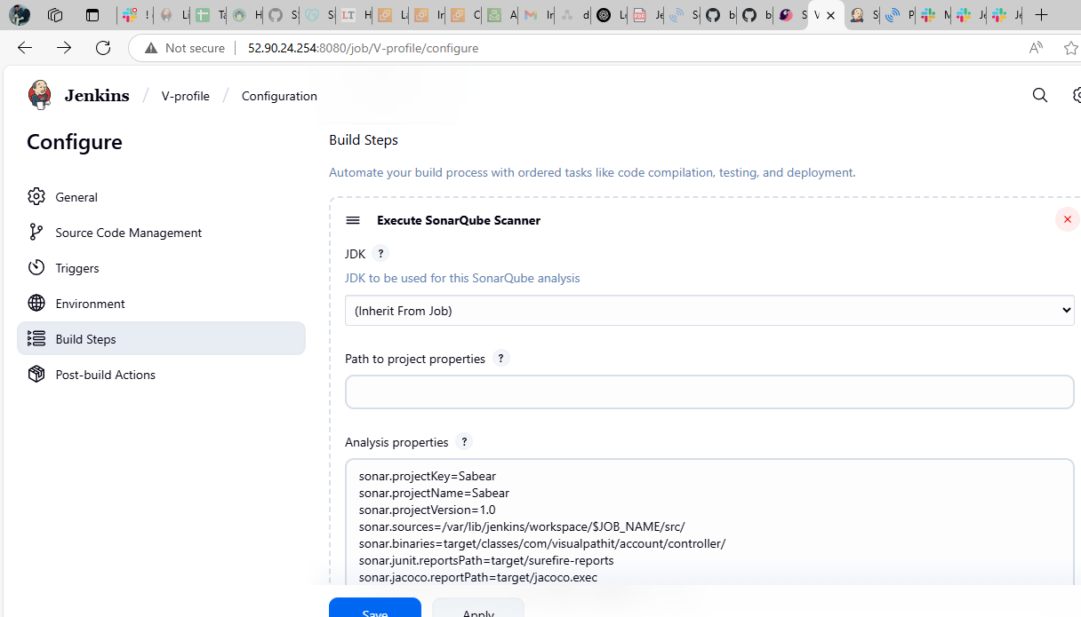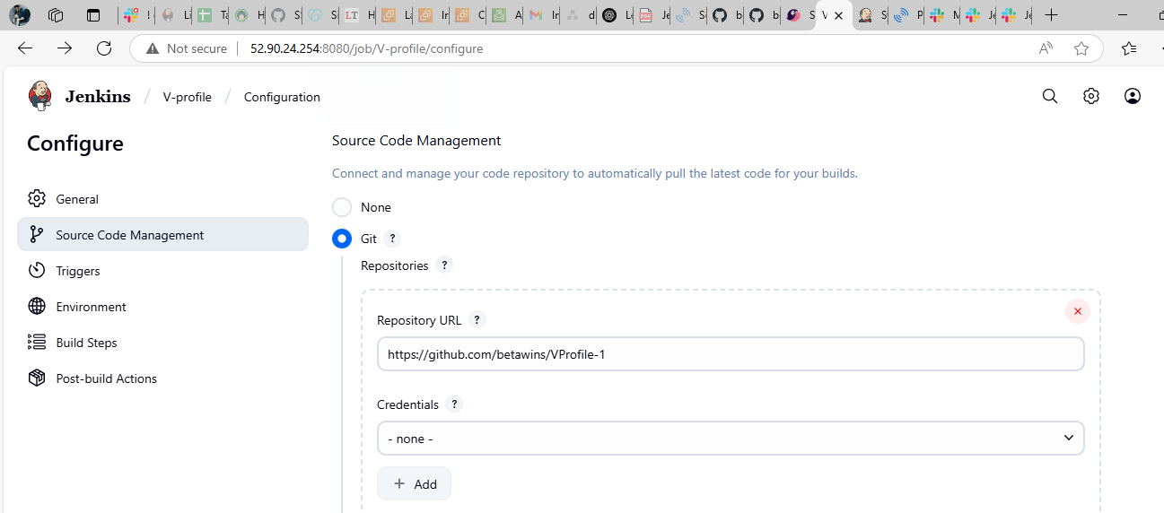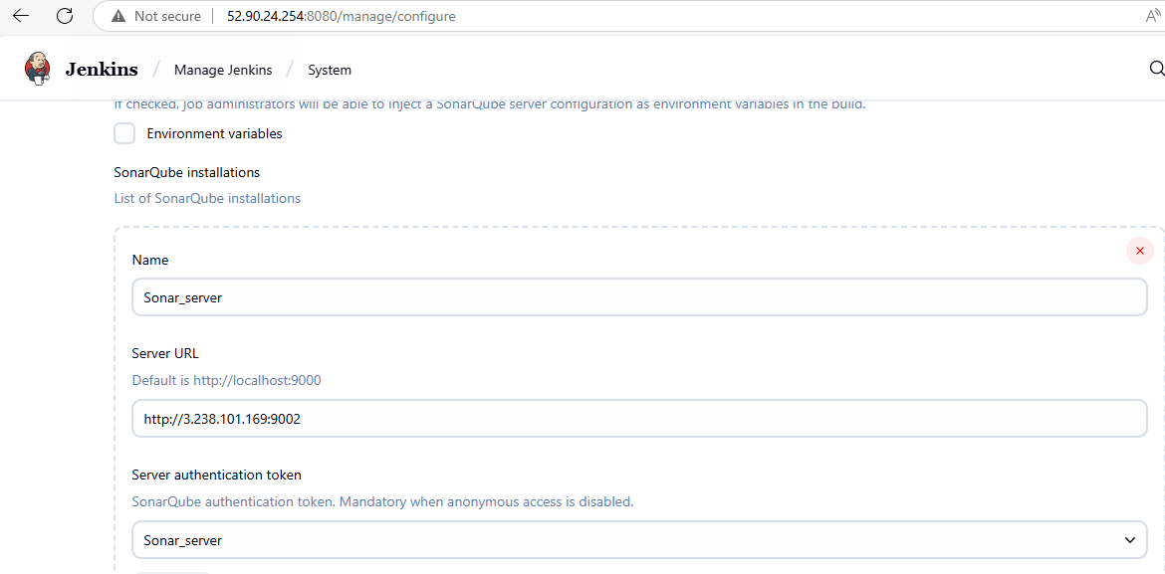Generate token from sonarqube and paste in secret in cred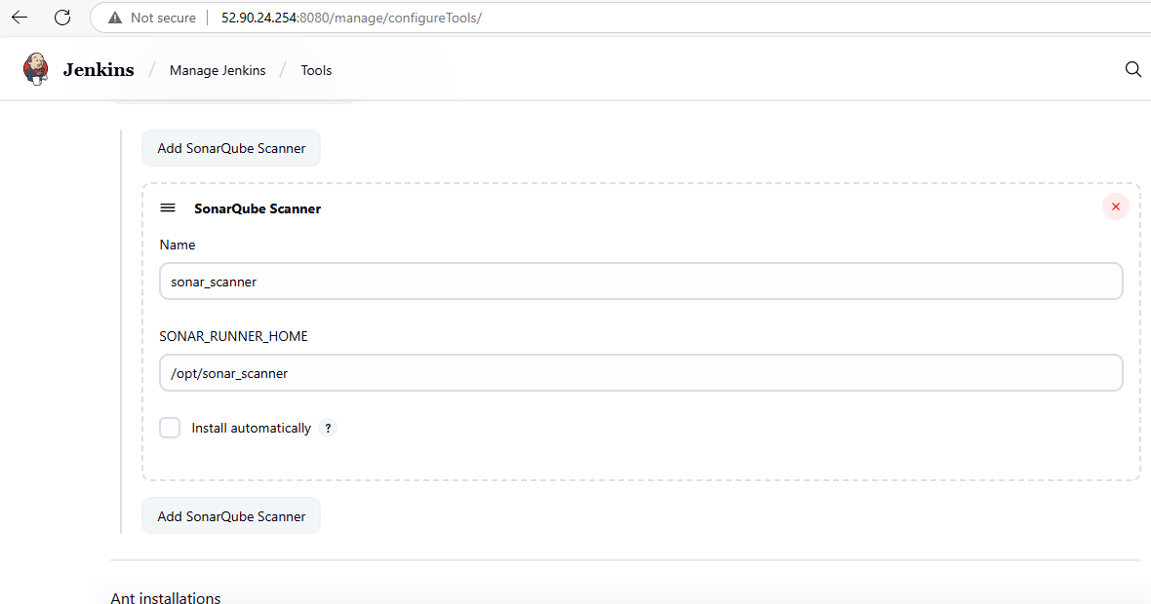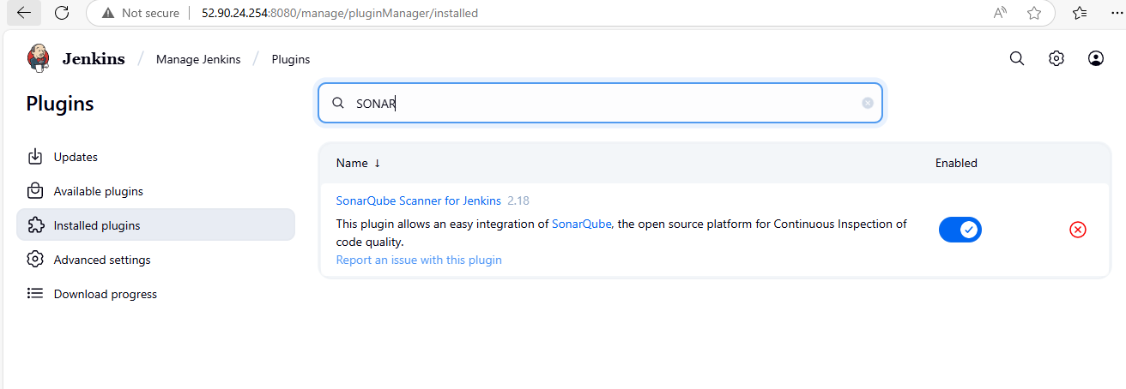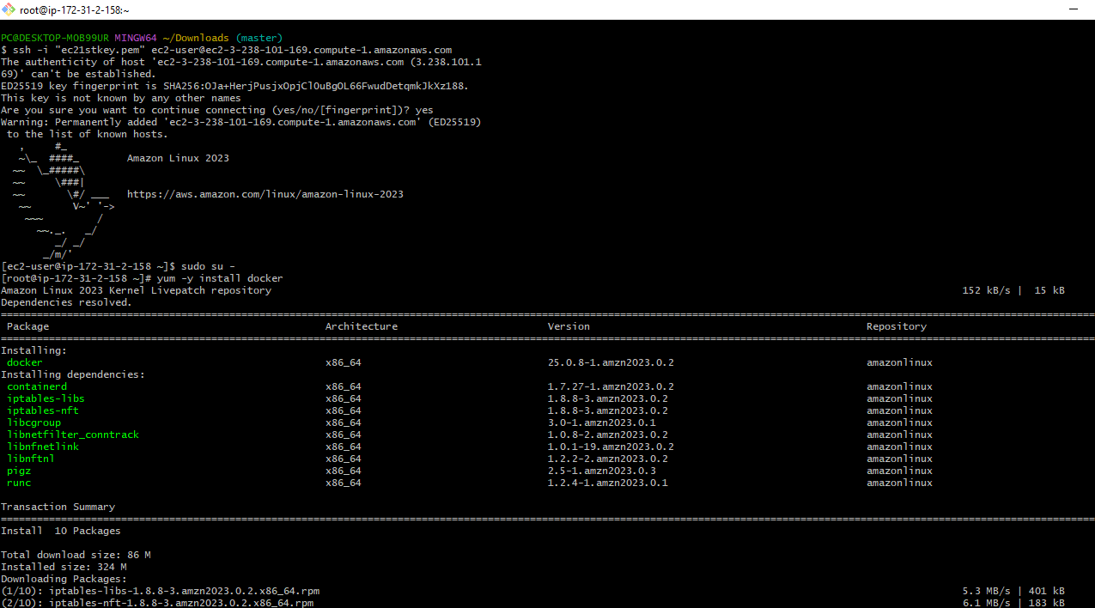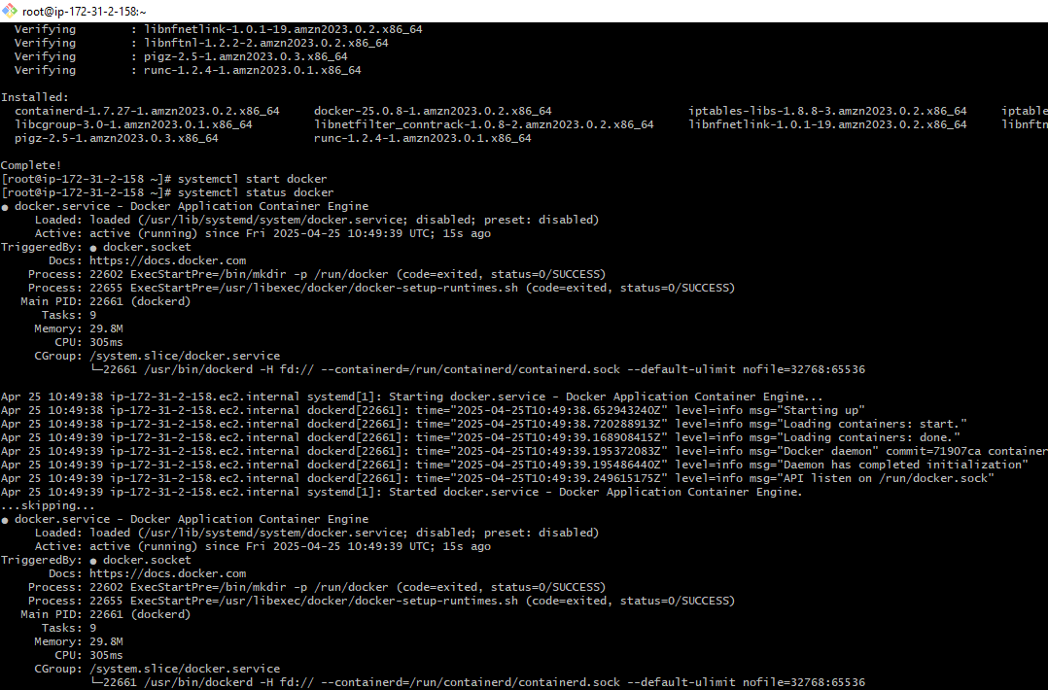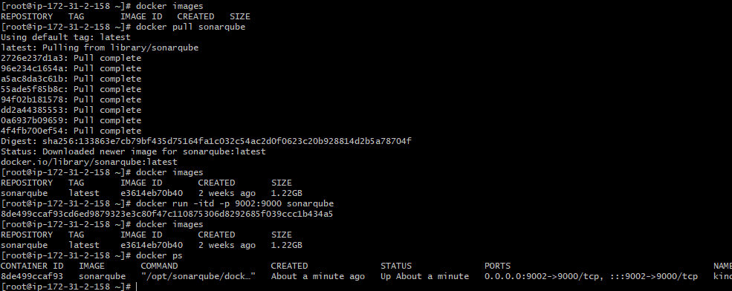

Sonarqube installed on docker

Installation of Jenkins and sonar SCANNNER on Ubuntu linux

* sudo apt update
* sudo apt install -y curl gnupg2 fontconfig openjdk-17-jdk
* java –version
* curl -fsSL https://pkg.jenkins.io/debian/jenkins.io-2023.key | sudo tee \

/usr/share/keyrings/jenkins-keyring.asc > /dev/null

* echo deb [signed-by=/usr/share/keyrings/jenkins-keyring.asc] \

https://pkg.jenkins.io/debian binary/ | sudo tee \

/etc/apt/sources.list.d/jenkins.list > /dev/null

* sudo apt update
* sudo apt install -y Jenkins
* sudo systemctl start jenkins
* sudo systemctl enable Jenkins
* sudo systemctl status Jenkins
* http://<your-ec2-public-ip>:8080
* sudo cat /var/lib/jenkins/secrets/initialAdminPassword